 University of Babylon

Collage of INFORMAION TECHNOLOGY

Software engineering

Moderated By: Huda Kadhim

REPORT BY: Programmer femo

Fatima Hassan Yasser

1437 A.H A.D 2017

**بسم الله الرحمن الرحيم**

(عَلَّمَ الْإِنْسَانَ مَا لَمْ يَعْلَمْ)

**"صدق الله العظيم"**

Dedicated to...

My Family,

My Teacher & My Friends.

With Great love.

Acknowledgment

Thanks to the God,

Thanks to everyone who stop by

my side,

Thanks to everyone who taught me,

Thanks to everyone who helped me

And Thanks to all.

Table of contents

Abstract 7

**Chapter One** 8

1. Introduction: 9

1.1 Overview: 9

1.2 Objective: - 9

1.3 Scope of the Project: - 10

**Chapter Two** 11

2.1 Requirements 12

2.2 Department of Archives 13

2.3 The surgical department:- 13

2.4 Use cases for the System 13

2.5 Requirement Table 14

2.5.1 Actor: surgery 14

2.5.2 Actor: Archive. 15

2.5.3 Actor: Management 15

2.5.4 Actor: - administrator 16

2.6 Flowchart 17

2.6.1 Management Flowchart 17

2.6.2 Admin Flowchart 18

2.6.3 Surgery Flowchart 19

2.6.4 Archive Flowchart 19

**Chapter Three** 21

**Analysis** 21

**3.1 Analysis** 22

This chapter talks about the system analysis 22

It includes diagrams that explain the system works, as well as details of the use case 22

It includes details of database 22

3.1 Class Diagram: 22

3.2 Use Cases: 24

3.2.1 Administration: 24

3.2.2 Surgery 25

3.2.3 Archives: 25

3.3 Scenarios: 26

3.3.1 The surgical department: - 26

3.3.2 Department of Archives 26

3.3.3 Department of Adman 28

3.4 Classes:- 28

3.4.1 Class Archive 29

3.4.2 Class Surges 30

3.4.3 Admin 31

3.5 CRC Cards 32

3.6 Data Base : 32

**Chapter Four** 34

**The Design** 34

4.1 Designing interfaces The project 35

4.1.1 Home Page : 35

4.1.2 About us page: 35

4.1.3 Contact us : 36

4.1.4 Login page: 37

4.1.5 Register page : 37

4.1.5 Management page 38

4.1.7 Admin Page: 39

4.1.9 Add new employee: 39

4.1.10 Add Production: 40

4.1.11 Report : 40

4.1.12 Transfer: 41

4.1.12 Archive page: 41

4.1.13 Surgery page: 42

T**able of figurs**

Figure 1 Use case of hospital management 15

Figure 2 Managemente flowcart 18

Figure 3 Class diagram 24

Figure 4use case-Administration 25

Figure 5use case Surgery 26

Figure 6: Home page 36

Figure 7: About page 37

Figure 8: Contact page 37

Figure 9: Login page 38

Figure 10: Register page 38

Figure 11: Management page 39

Figure 12: Admin page 39

Figure 13: Adding page 40

Figure 14: production page 40

Figure 15: Report page 41

Figure 16: Transfer page 41

Figure 17: Archive page 42

Figure 18: Surgery page 42

Figure 19: Appointment page 43

# Abstract

Hospital management system: This system was established to solve some of the problems that may be facing the customer and the main goal of the system is provide to customer potential of moving through various sections in order to make him more comfortable and pleased of using it. This will happened in accordance with particular basics for solving the troubles. In addition to that, there are some specific instructions which placed by the hospital to accept the person who applied for a job. The first step after getting the work is store the collected information in the Archives department (which contains all data &information that are pertaining to the system) .Then move to the Operation department (surgery), the Tastiest department that has several parts that support the system by providing the times field, for instance the specific time of each operation in order to prevent the collision in the times of operations for the doctor. Another example of the section you can know the number of patient's room to facilitate the work for everyone, there is other department you can see in the hospital when moving in it. This Schedule tried to provide opportunities to solve problems despite of obstacles. We aspire to develop the system in the future.

# **Chapter One**

Introduction

## Introduction:

### 1.1 Overview:

Hospital Management System is a simple, flexible and safety software program that we expected to use it in hospitals that at the moment still using papers in different situations. Unlike the papers, this software system is adjustable(we can change the information inside it easily without losing any existing information ) and it is very reliable.

We mean by (reliable) that it is very accurate and the information that we entered to this system are safety (non-perishable). Hence, all the information stored in one place so we can reach it with minimum time and less effort.

Hospital Management System has many profits besides what we mentioned above . Hospital Management Systemhelp to improve the quality of managing the hospital and this enables you to develop your organization and improve its effectiveness and quality of work.

### 1.2 Objective: -

1. Define management of the hospital.
2. Recording information about the Doctor that come.
3. The work of the Director General.
4. Series the arrival of the c v doctor.
5. The work of the technical section.
6. The work of the Department of relations and media.
7. Opening hours.
8. The Department of archives.
9. Department of surgery.

10)Upgraded the doctor or staff.

These are the various jobs that need to be done in a Hospital by the operational staff and Doctors. All these works are done on papers.

### 1.3 Scope of the Project: -

1. Register new doctor Information including the doctor name, age gender, Document graduation, Living, phone number.
2. If approved appoint a doctor, the doctor will be giving details of his work.
3. Determine work time.
4. Store staff and doctor’s information.
5. Upgrade and sanctions.

All this work is done manually by the receptionist and other operational staff and lot of papers are needed to be handled and taken care of.

# 

# 

# **Chapter Two**

Requirements

## 2.1 Requirements

In general, initially the system will be limited to his work on several sections and each section will be is responsible for the specific task.

**Firstly the functional of the system**

First: At the advent of a new case of a doctor in order to work , would ask him to hospital administration

The first thing for the doctor when apply for work and accepted in the hospital, he needs to provide the following information:

1-Full name.

2-Age.

3-Living.

4-phone number and email.

**5-**Graduation Documents**.**

Then he has to wait for the acceptance or rejection of his application form his information to go to the Department of archiving for storage and these actions take place to the doctor or the new employee and have as tow section.

Primary and secondary, in the case out Mode or doctor to retire the application form kept in the center of the circle either in the case of transmission of an employee to a new city, they are sent to the new city, either Pell’s to the issue of promotion and sanctions that are given to employees and doctors, they are added to form their own, this task is important archives and administration department.

The Director-General to agree to form a doctor and then send two copies to the operations and consulting for the creation of his room and then queries the news to give in order to receive a doctor and then news of Communications and Media Department in order to hand over the identity of the new doctor.

**Secondly, the non-functional of the system**,

generally this part has its own significance in requirement of the system for instance the number of using computers in each section of the hospital management system, it is worth mentioning the computer of Manager (Administrator) which possesses high specifications and thus gives him the exclusive right to add any alteration to enhance the system (insert, delete, update) for the Database shall be synchronized and done only by him. Another example the computers which used by archive’s agents that may be has more than one employee.

In the other hand this part involves the nature of the work of the rhymester inside the hospital that can used locally within hospital administration , so cannot applied by any person from the external environment who has no guarantee of accessing the system. Overall the all interfaces will be easy and flexible for the user.

After the presented information this part could include various sides for keeping the system,

let’s start with **the security side** which contains(Patient Identification and Login ID )   
The system ask the patient to identify himself /herself, and any user who joins to system would have to use his unique login ID and password.

Then point out to the **Maintainability** and **Reliability** sides of the non-functional that implicate:

Back Up The system provide the capability to back-up the Data.   
 ErrorThe system save a log of all the errors.

While the **Reliability** means Availabilitywhich grants the system will be available all the time

In addition to understanding part of non-function requirement it will work on **Performance Requirements (Response Time, User-interface**, **and Capacity).**

### 2.2 Department of Archives

This section of the system be his job to save all staff and patient information, as well as the ability to view employee information

**.**

### 2.3 The surgical department:-

This section is responsible for:-

1. Book an appointment for the patient.

-Patient name.

-The patient's age.

-The patient's title.

-No. patients.

2. If the patient does not need an operation, the doctor gives the patient treatment.

3-.If the patient needs to process the physician will transform the patient to the operating room surgery department but before the start of the operation must:-

-Determine the operating room.

-Determine the date and time of the procedure.

-room number.

-Patient name.

-The doctor who conducted a process.

## 2.4 Use cases for the System

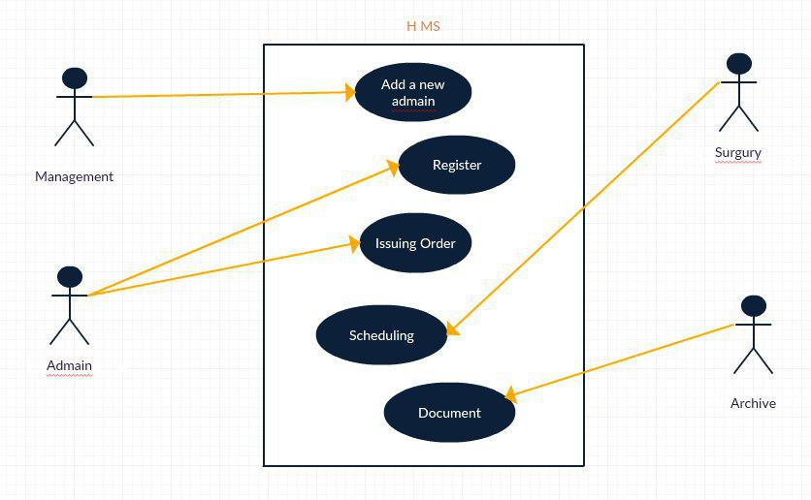

Figure 1 Use case of hospital management

|  |  |
| --- | --- |
| appointment | requirement |
| Give the time for operation and indicate the time of the doctor. | Description |

## 2.5 Requirement Table

## 2.5.1 Actor: surgery

## 2.5.2 Actor: Archive.

|  |  |
| --- | --- |
| Save | requirement |
| Save the information for any employer in hospital. | Description |

## 2.5.3 Actor: Management

|  |  |
| --- | --- |
| Great account | Requirement |
| Great account for admin for the system and accept the request when the admin want a new account | Description |
| Log in | Requirement |
| Make the access to the departments | Description |

## 2.5.4 Actor: - administrator

## 

|  |  |
| --- | --- |
| Register | Requirement |
| Register a new employee. | Description |
| Add upgrade or warring | Requirement |
| Add upgrade or warring for any employ on the table of the employ. | Description |

# 2.6 Flowchart

## 2.6.1 Management Flowchart

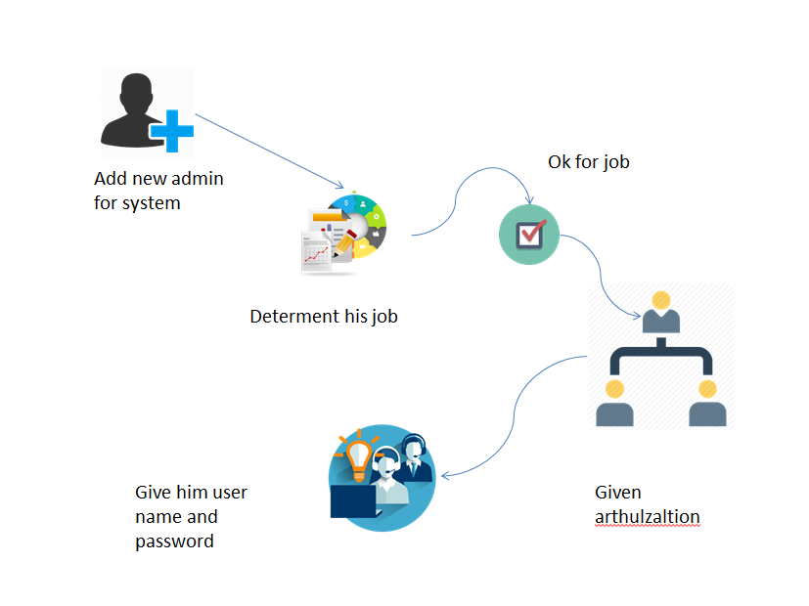

Figure 2 Managemente flowcart

## 

## 2.6.2 Admin Flowchart

## 

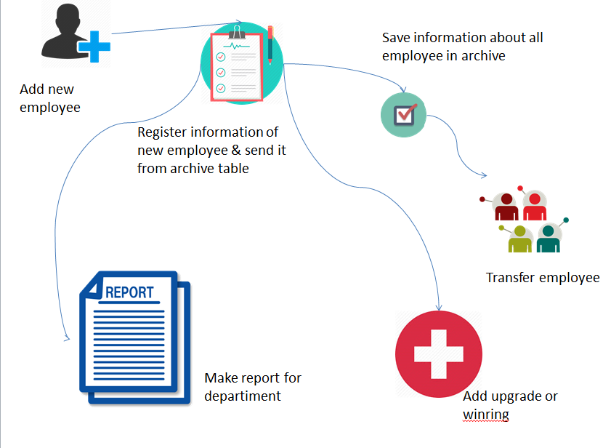

## 

## 

## 2.6.3 Surgery Flowchart

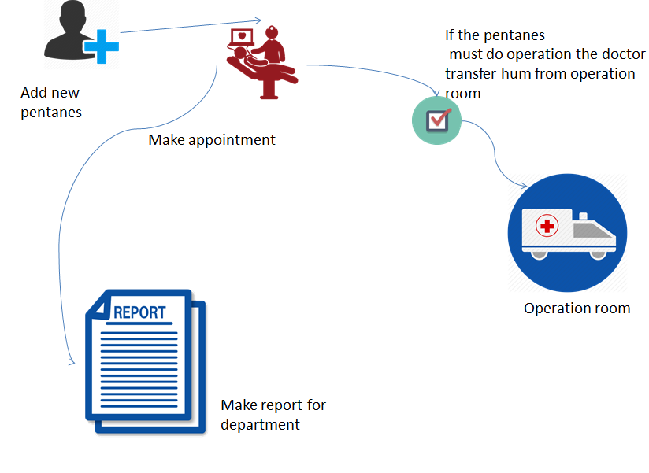

## 

## 2.6.4 Archive Flowchart

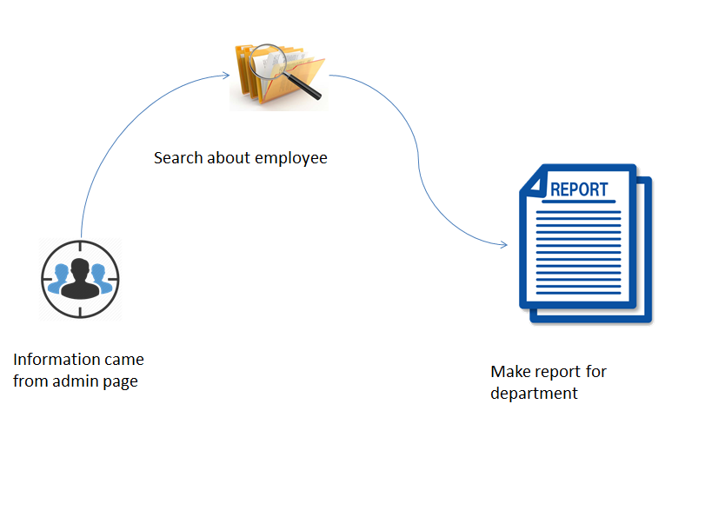

# 

# 

# 

# **Chapter Three**

# **Analysis**

## 

# **3.1 Analysis**

## This chapter talks about the system analysis

## It includes diagrams that explain the system works, as well as details of the use case

## It includes details of database

## 3.1 Class Diagram:

This is class diagram contains a description of the work of the system where he explains the work of each section of the system.

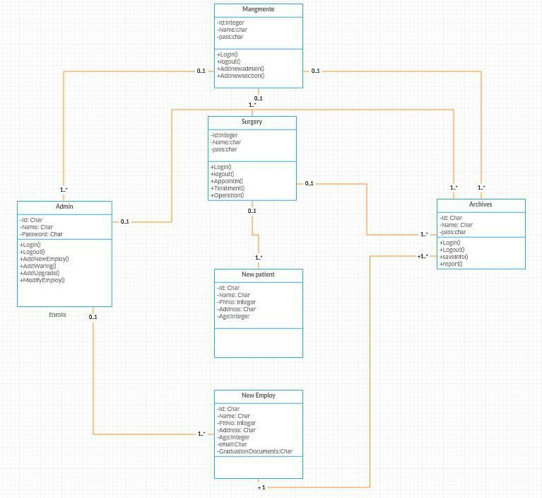

Figure 3 Class diagram

### 3.2 Use Cases:

3.2.1 Administration: - 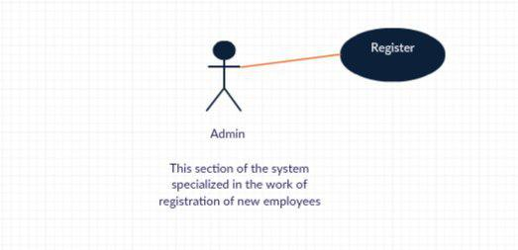

Figure 4use case-Administration

### 3.2.2 Surgery

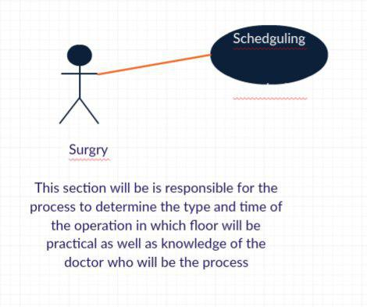

Figure 5use case Surgery

### 3.2.3 Archives:

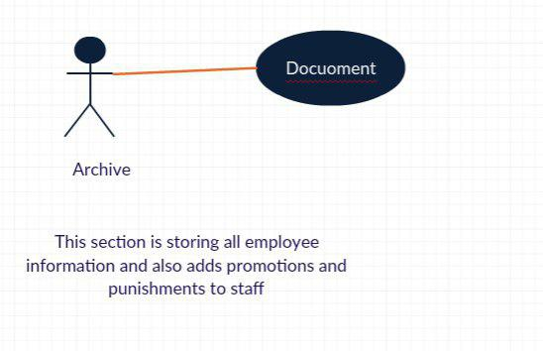Figure (5) use case -Archives

## 3.3 Scenarios:

### 3.3.1 The surgical department: -

## Define the beginning of the process and the time of the end of the process time.

## 1. Dr. Name.

## 2. The patient's name.

## 3. No. operating room.

## 4. Floor number.

## - Because the Department of Surgery has 3 floors so determine the floor number to the process occurs and room number.

## 5. Date of the operation.

## - Define the process history day, month, year and time to contradiction other processes does not occur.

## 3.3.2 Department of Archives

Dr-new

1) Open a new file.

2) Information Form (archives of the four), and document graduation, the health of the issuance of the document, is in the direct administrative, disintegration of the canter of the circle.

3) Enter the information into the computer (electronic documentation of all information).

4) enter into their own hard.

      1-any book received by Doctor sends new to the circuit and saves in the dossier your own.

         A) Administrative orders.

         B) Leave + the official books.

         C) Orders bonuses and promotions.

         D) Promotion + sanctions and alarm.

         E) Alarm and draw attention and riots.

      2-transport from one province to another province is the transmission of a final dossier.

5) There is destroying the file completely.

1_Each employee has request from him form praise contain some information about him like (name, birth, address, phone number, graduate document).

2_The document graduate has been seen by general director (boss) and relations department and art department which divided into consulting and surgery.

3_if has been approved of him turn to surgery and consulting then preparing the room and give news to the queries for reception the doctor then give identification to the new doctor to proceed the work.

4_then receive special time table for him.

5_the official working divided into three department:

1. Morning ,

From 7:00am to 2:00pm.

Or

From 8:00am to 3:00pm.

1. Evening ,

From 2:00 pm to 9:00pm.

Or

From 1:00 pm to 8:00pm.

1. Night Shaft,

From 8:00pm to 8:00am.

Or

From 10:00pm to 10:00am.

6_If the employ is a doctor then his work as for resident doctor and his official working is 12 hours or non-resident and his official working depends on special system hosp.

### 3.3.3 Department of Adman

## 1-serves the request of the person and the job

## 2. Requires the employee's record and acceptance of information include (full name, age, address, mobile number and a document graduation)

## 3-manager of information received and the acceptance or rejection by controls

### 3.4 Classes:-

### 3.4.1 Class Archive

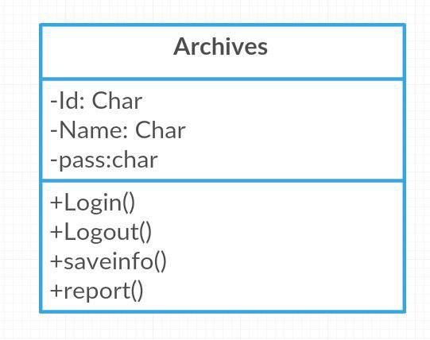

### 3.4.2 Class Surges

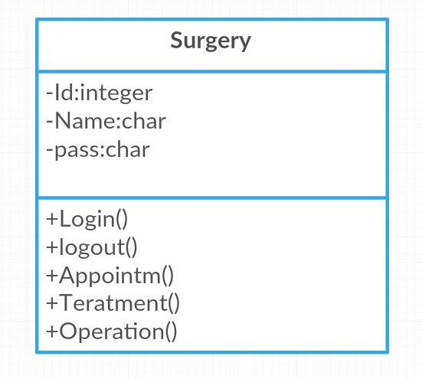

### 3.4.3 Admin

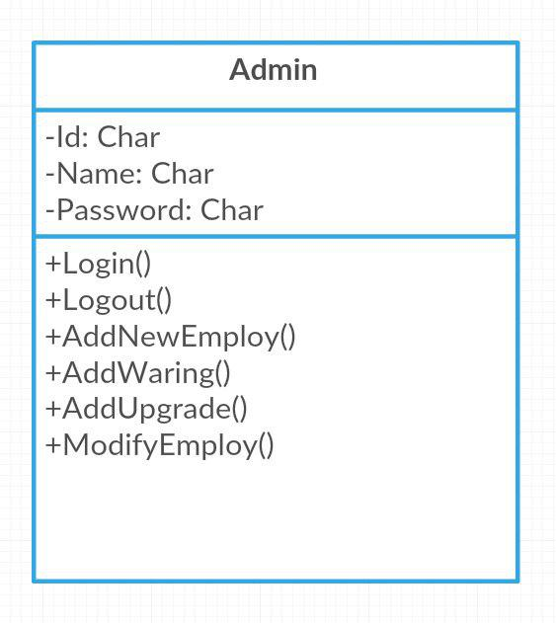

### 3.5 CRC Cards

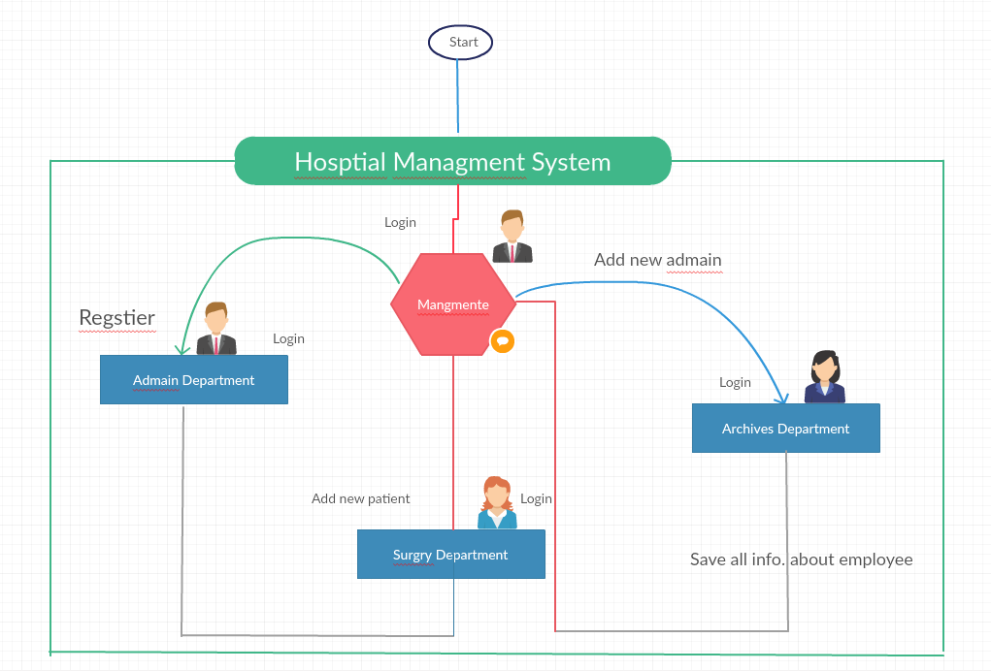

Figure(6) CRC Card

## 3.6 Data Base :

In this section we will talk about the database.

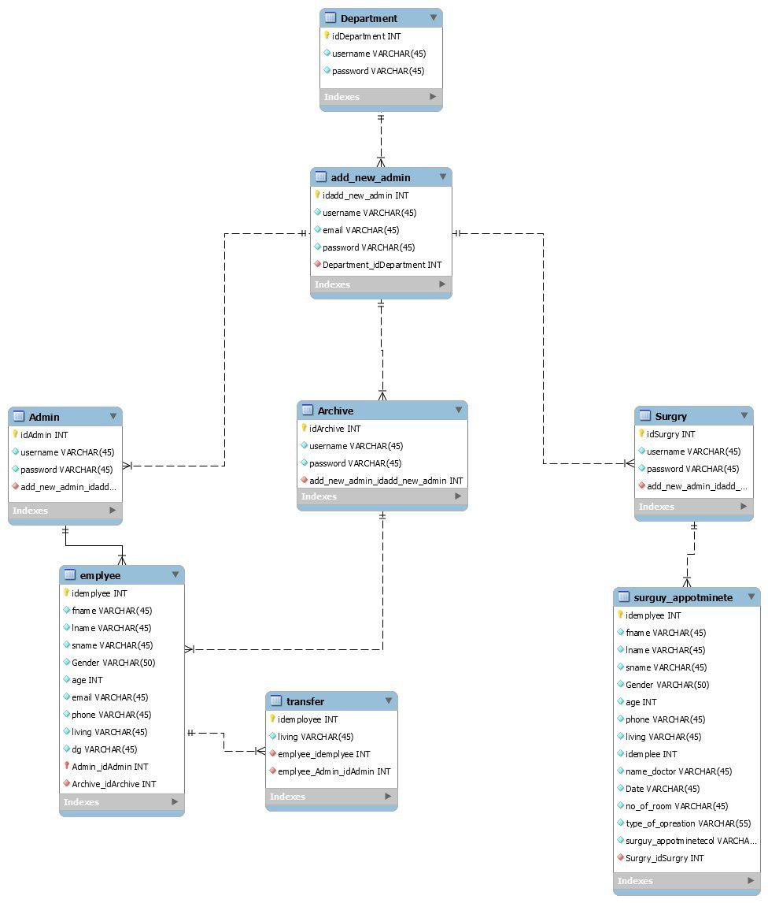

# 

# **Chapter Four**

# **The Design**

## 4.1 Designing interfaces the project

This chapter is talking about the project Designing

So that it includes all the Designing and interface of interfaces the project

### 4.1.1 Home Page:

When an employee is visiting the site, this page will be the main in other words, is the first page in the site contains sections of the website as well as the definition of the site.

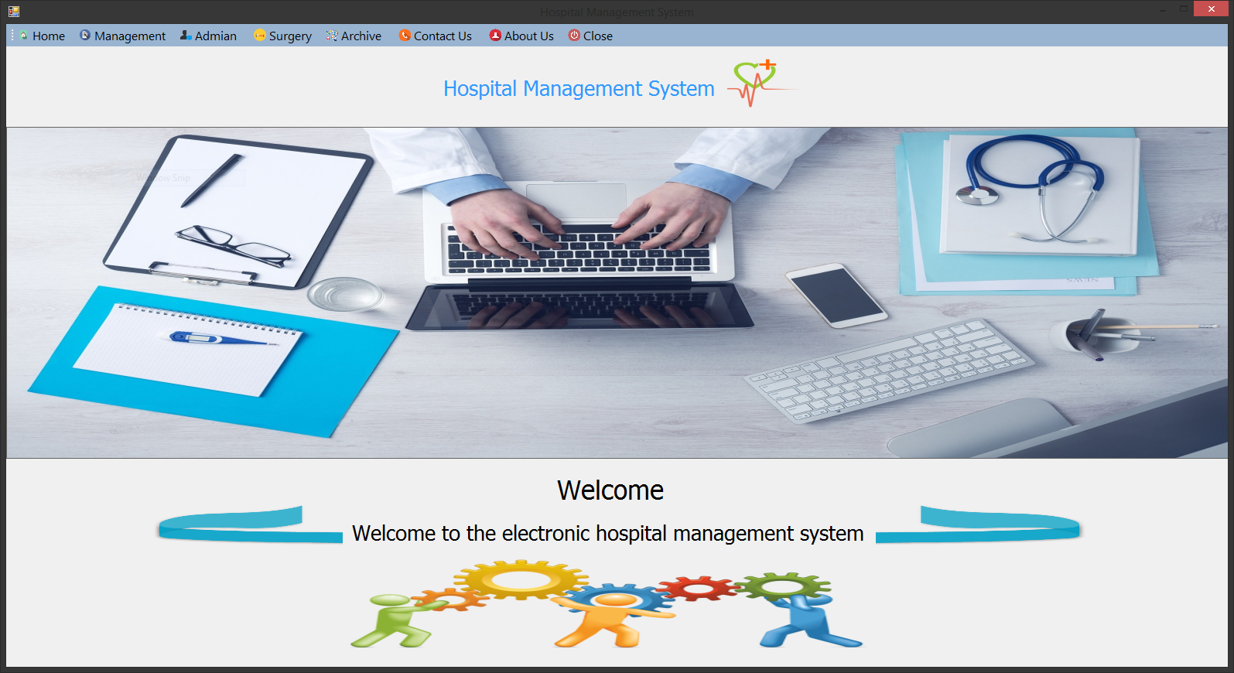

Figure 6: Home page

### 4.1.2 About page:

This page includes information on the designer’s website.

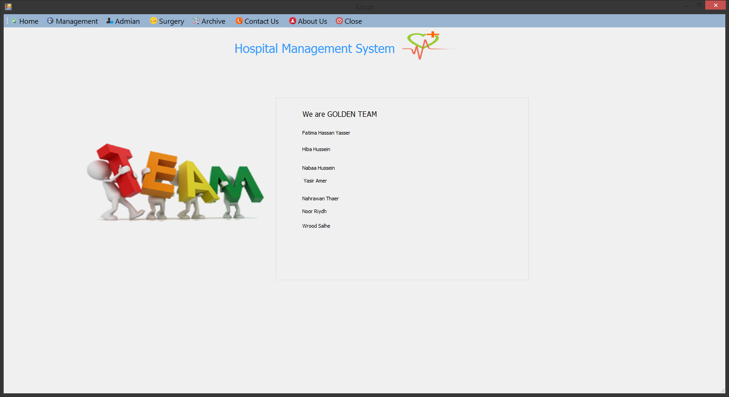

Figure 7: About page

### 4.1.3 Contact us:

This page includes communication by those who designed the site information

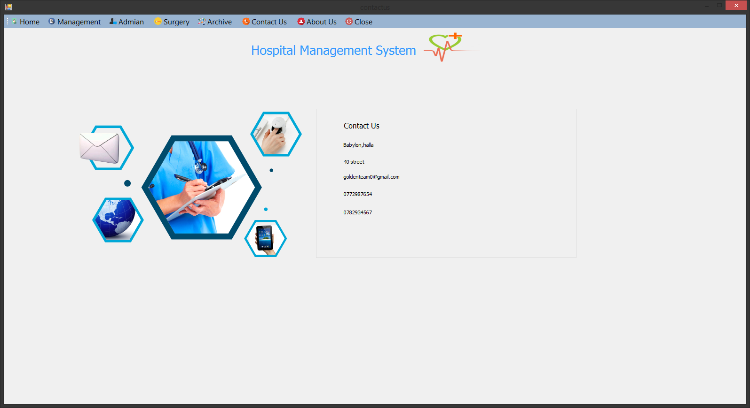

Figure 8: Contact page

### 4.1.4 Login page:

This interface in order to log on to the system for the administration used the system administrator.

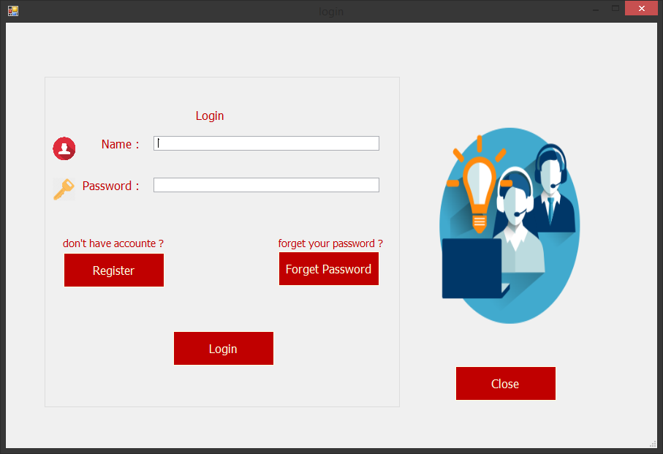

Figure 9: Login page

### 4.1.5 Register page:

This interface enables the system administrator to create a new account if forgot his account code.

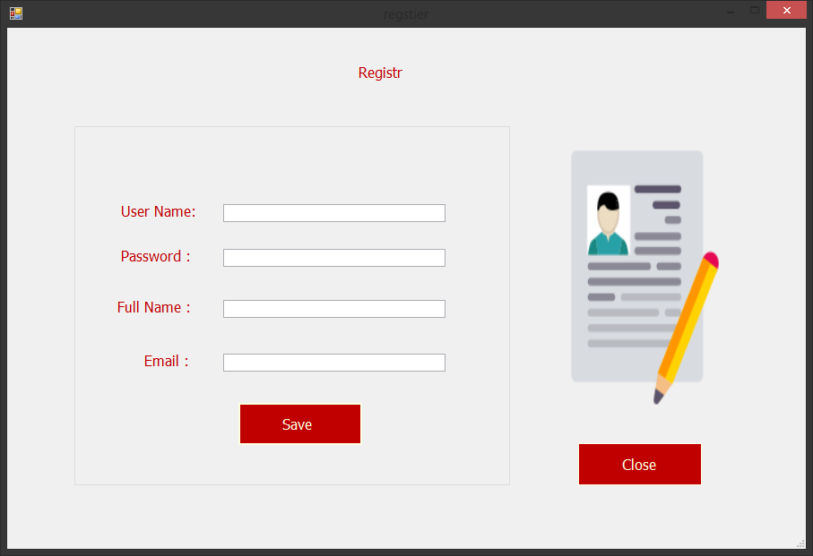

Figure 10: Register page

### 4.1.5 Management page

This interface is the interface, Administration Division Function register a new employee.

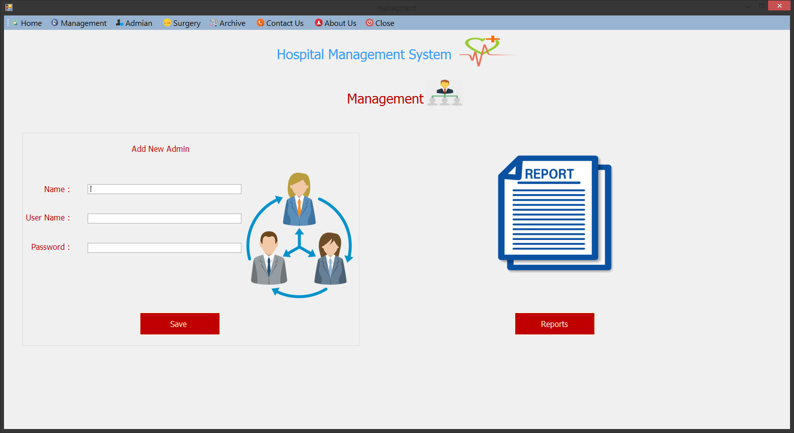

Figure 11: Management page

### 

### 4.1.7 Admin Page:

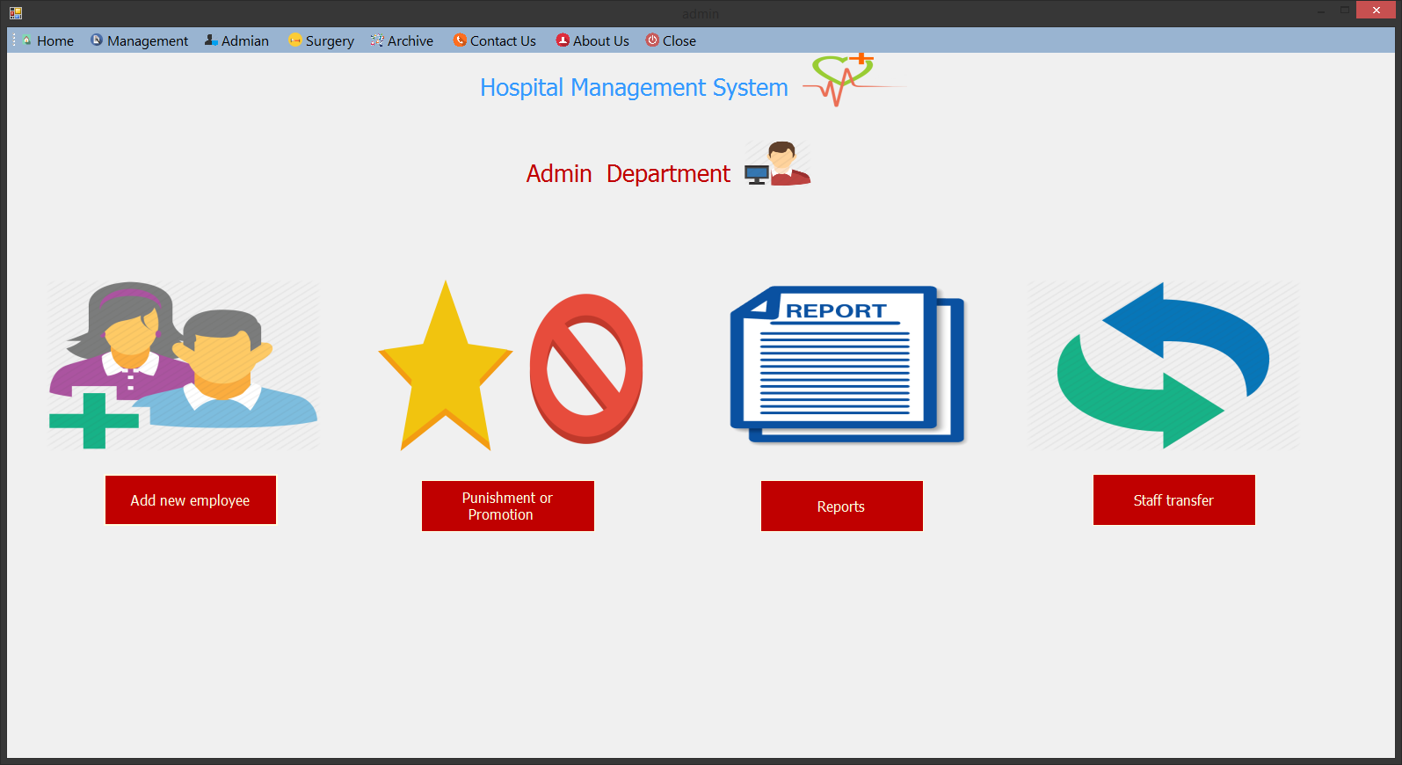

Figure 12: Admin page

### 4.1.9 Add new employee:

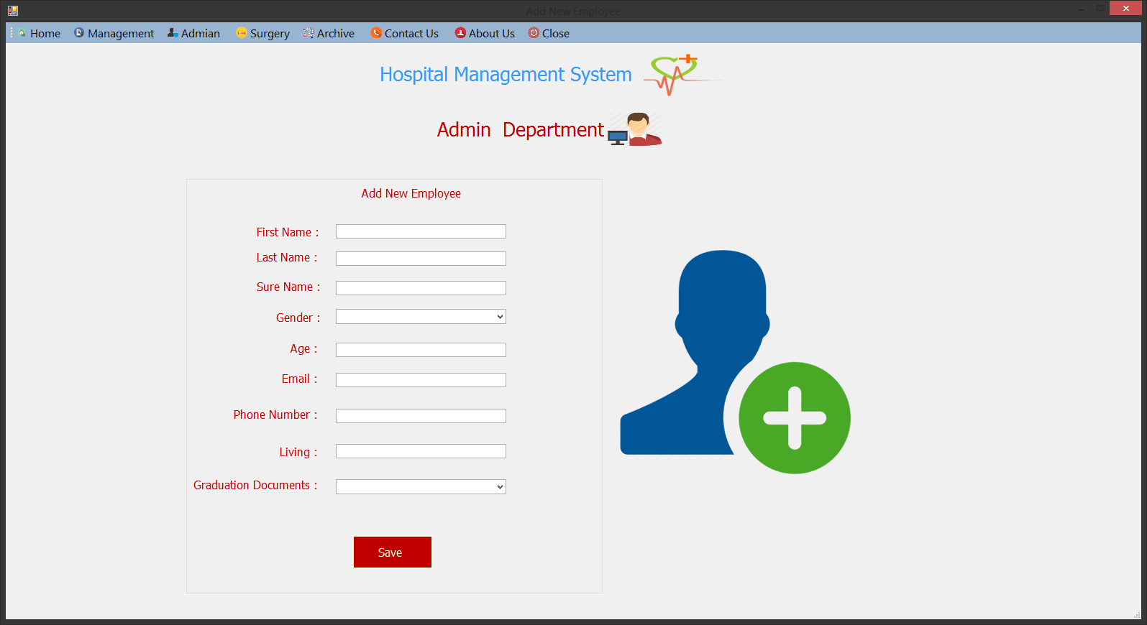

Figure 13: Adding page

### 4.1.10 Add Production:

### 

Figure 14: production page

### 4.1.11 Report:

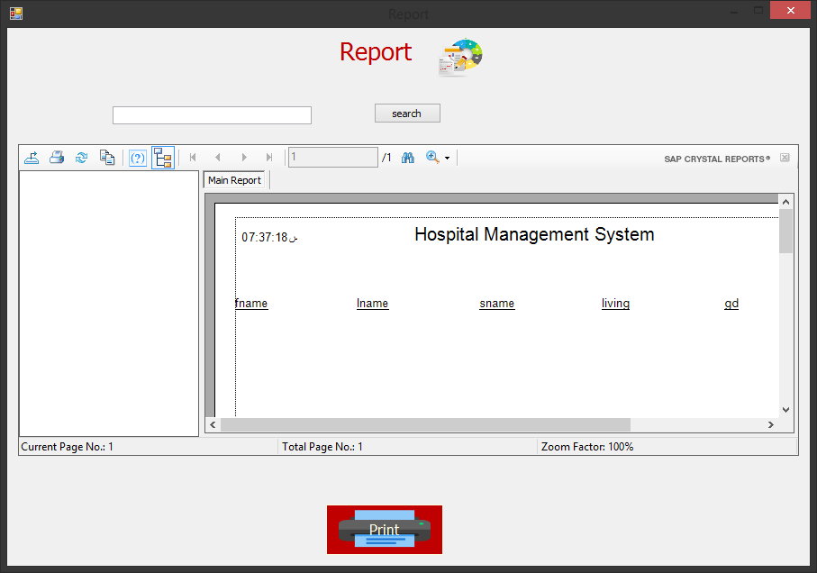

Figure 15: Report page

### 

### 4.1.12 Transfer:

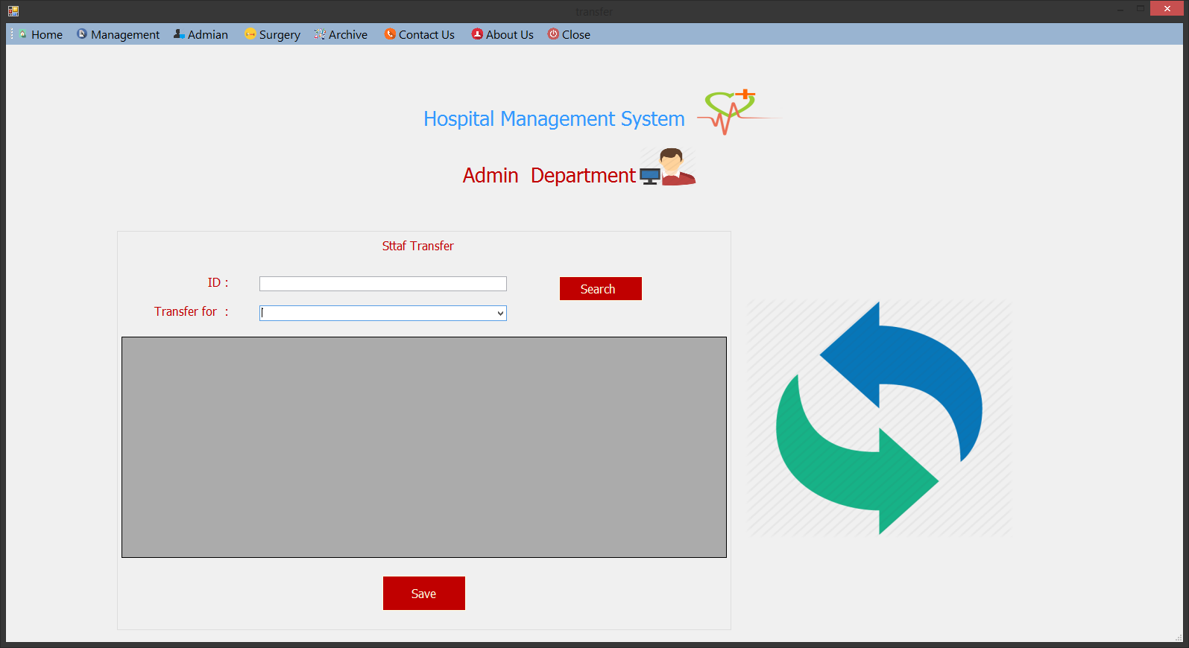

Figure 16: Transfer page

### 4.1.12 Archive page:

This interface is the interface where the archive section contains the control panel of this section.

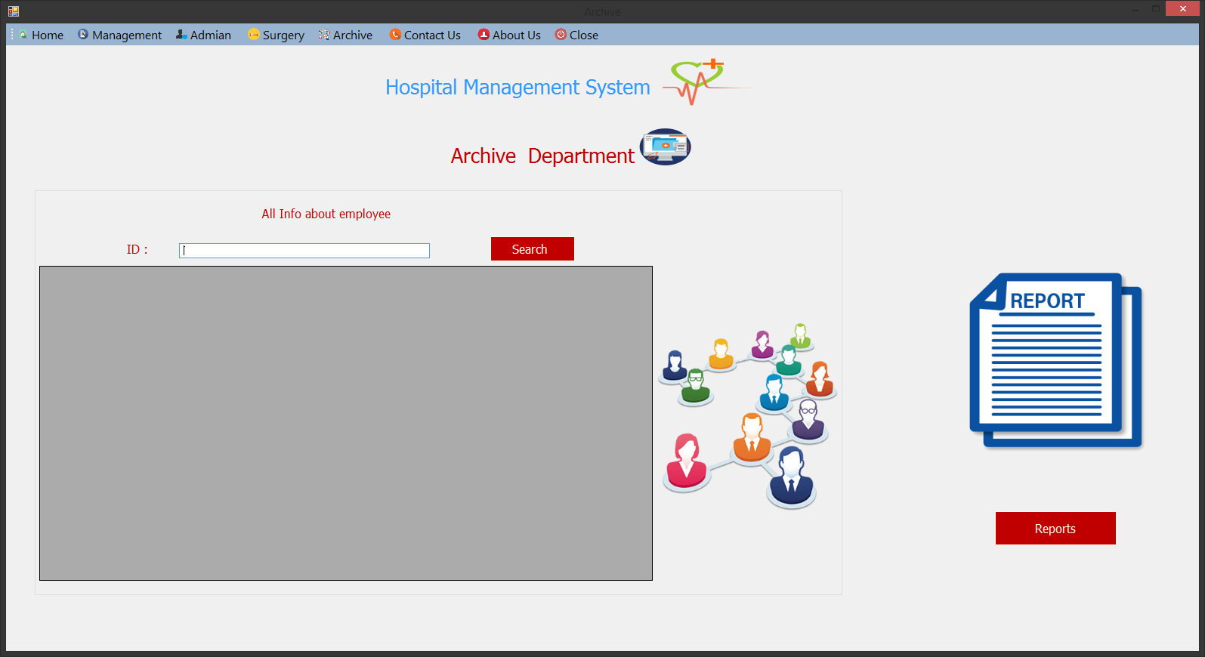

Figure 17: Archive page

### 4.1.13 Surgery page:

This interface is representing the Department of Surgery and the interface contains the control panel of Surgery Department.

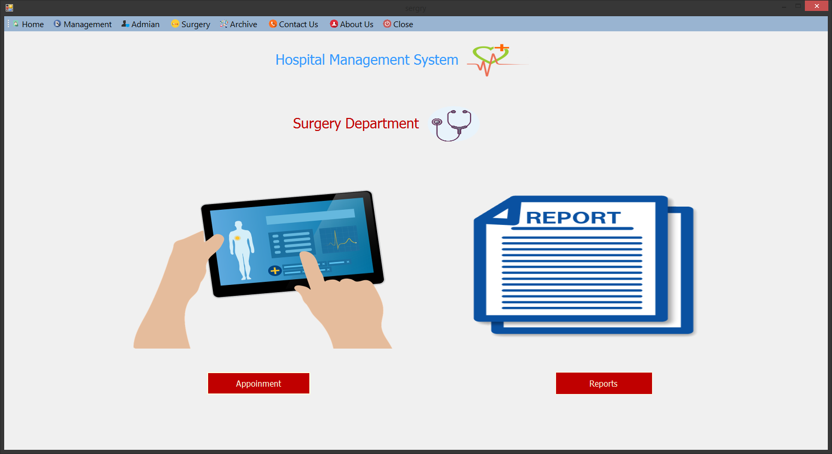

Figure 18: Surgery page

4.1.14 Add Appointment:

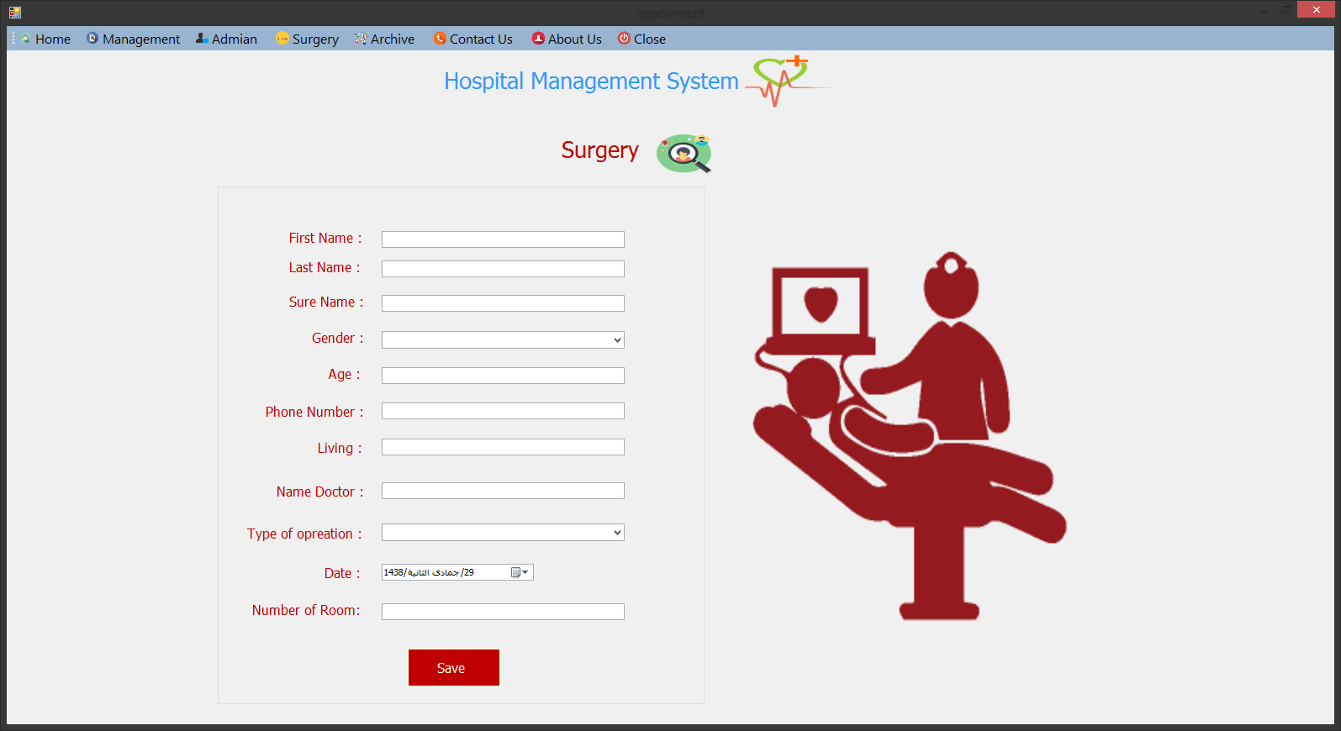

Figure 19: Appointment page

The End